What’s the Buzz? Optimizing Manuka Honey

### 

### 3.1 Introduction: Growing Stuff in NZ

Agriculture and related activity is a very large part of New Zealand’s economy. Agriculture accounts for about ⅔ of New Zealand exports and employs about 6% of the workforce.

New Zealand has been a leader in innovation in agricultural technology. Many people are familiar with the development of non-shortable electric fence technology that was developed in NZ in 1962, and this kind of innovation continues even today. Engineering graduates of all kinds may be able to find employment in the agriculture sector in NZ.

In this lab exercise we will explore a real-world problem that was brought to Professor Mark McGuinness as a consulting project. The project involved (and the lab involves) work with now world-famous Manuka Honey (MH). MH commands a very high price in New Zealand and internationally. It is thought by many to have very beneficial health effects in general and antimicrobial properties in particular.

The key point for an engineering student is that this lab helps you develop skills in modelling systems that are quite marketable and will help you with further classes. In fact, it might help you get your bee average by cross-pollinating some ideas from maths, science, and engineering, even if the calculus makes you break out in hives. Ouch. That stings.

### 3.2 Review and Warm-up

#### CORE 1: Maximums

Consider the function $f(x)=3+10x-2x^{2}$. Find the maximum of this function: find the value of *x* at which *y* is a maximum, and find the corresponding value of *y*. Describe the shape of the graph. Hnt: you can complete the square and use the properties of parabolas, or you can use calculus. Better yet, why not do both and verify you get the same answers?

*******************************************************************************************************

This graph will be a parabola with a negative gradient, so it will look a lot like a hill.

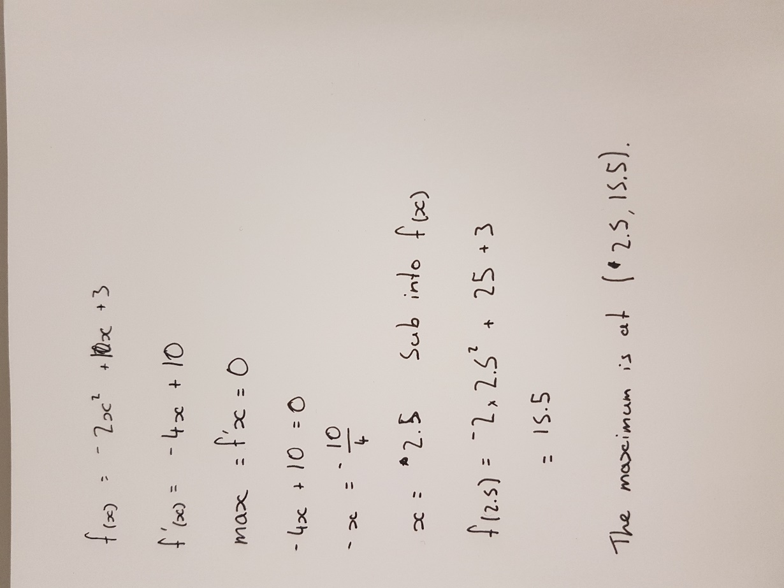

*******************************************************************************************************

#### 

#### CORE 2: Spreadsheets

Use LiberOffice Calc (very similar to Excel) to graph the function and verify your results. A tutor will show you how to do this. Insert your graph.

*******************************************************************************************************

*******************************************************************************************************

#### Parameters in a Function

Sometimes an engineer knows the general form of an equation but the equation has parameters that need to be determined experimentally. An example might be the stopping distance of a car which has the general form

$$D=\frac{v_{I}^{2}}{2β}$$

Where *D* is measured from the point at which the brakes are applied and $β$ is a parameter that depends on the tyres, road, weather, and whatnot. $v_{I}^{}$ is the speed of the car just before the brakes are applied.

#### CORE 3: A Stunt

A movie stunt director wants to know what stopping distance he should assume for a movie stunt. The speed of the car will have to be adjusted on the day to get the scene right, so the stunt director needs a formula for stopping distance in terms of initial speed. Luckily the environmental conditions are very constant so $β$ will not change. The engineer asks the stunt driver to do a test run, accelerating to 30 m/s and stopping. She measures the stopping distance to be 52 m. Find the parameter and write a formula for the stunt director to use.

$$β= 0.5\frac{v_{I}^{2}}{D}$$

$$β=8.65$$

$$D=\frac{v_{I}^{2}}{17.31}$$

*******************************************************************************************************

*******************************************************************************************************

### 3.3 The Honey

As bees visit Manuka flowers they collect an ingredient called dihyroxyacetone (DHA). After Manuka Honey (MH) is harvested DHA changes into methylglyoxal (MGO). It is MGO that gives the MH its celebrated antimicrobial properties.

* The process that transforms DHA to MGO is accelerated at higher temperatures, but if the honey is kept warm too long we will eventually start to run out of DHA to convert and then both the DHA and MGO concentrations decrease. Luckily, when the honey is cooled the process essentially stops and the concentrations of DHA and MGO are frozen.
* We want to measure the MGO concentration and freeze it when the MGO concentration is a maximum. But testing for MGO is expensive. Testing for DHA on the other hand is cheap. So we want to develop some mathematics that predict the MGO concentration given the DHA concentration. Then we can monitor DHA only while the honey ages, and cool it at an optimal time. This turns out to be a bit complicated.

#### An Engineering Approach: Model the System

We are not worried about sorting out the details of the biochemistry. We want to know when to cool the honey. So we will make a model of the system. The beekeeper used a typical engineering approach. At significant cost he measured the DHA and MGO concentrations for batches of honey and found upper and lower curves that describe how the two variables are related.

Let’s call the DHA concentration *x* in percent for example, and the MGO concentration *y*. We find two calibration curves, and upper and a lower:

$y=L(x) = 4x-x^{2}$ Lower

$y=U(x) = 2x-x^{2}+15$ Upper

COMPLETION 1:

Graph both of these functions on the same axis over a suitable range of *x*. Hint: what feature(s) need to be present in your graph? Remembering that *x* and *y* are concentrations of chemicals, What is the lowest possible value of *x*? What is the lowest possible value of *y*?

*******************************************************************************************************

*******************************************************************************************************

COMPLETION 2:

If you knew your honey was described by *L*(*x*), at what value of *x* would you cool it? What about for *U*(*x*)? Hint: you can use calculus or you can complete the square and use properties of parabolas.

*******************************************************************************************************

*******************************************************************************************************

#### A Model

But the trouble is that every batch is different. Agan, thinking as engineers, we need to make a **model of the system** that is easy to use and also effective enough to be worth using. In this case **we assume that all batches of honey lie somewhere between the upper and lower calibration curves *L*(*x*) and *U*(*x*).**

Consider a real batch *h*(*x*). We assume the concentrations are related by

$$H(x) = λU(x)+(1-λ)L(x)$$

If you set $λ=0$ you have *L*(*x*). If you set $λ=1$ you have *U*(*x*). For any other value between 0 and 1 we have a curve that lies between the upper and lower curves. This is called a **homotopy** - a function that evolves smoothly from one function to another as the parameter $λ$ ranges from 0 to 1.

**This equation summarizes our engineering model. The “proof” is just whether it works. It’s relatively simple and worth a try. It turns out it does work.**

COMPLETION 3:

Graph *H*(*x*) for $λ=0.5$ on top of the other functions. See how it works? If you know what lambda is you can monitor *x* and stop the reaction at the optimal time for that batch.

*******************************************************************************************************

*******************************************************************************************************

We can find $λ$ if we measure both MGO and DHA once. Then we have *h*(*x*) and only need to measure DHA (cheaply) to optimize the antimicrobial characteristics of our honey.

#### Sweet!

COMPLETION 4:

So Beekeeper Buzz measures a batch of honey and finds *x* = 3, *y* = 6. Find lambda, *H*(*x*), and tell Buzz the value of *x* at which he should cool his honey. Tell him what the MGO concentration will bee. Hint: plug the data into *H*(*x*) and solve for $λ$.

*******************************************************************************************************

*******************************************************************************************************

OK you’ve got this far in the lab. Get some tea. With Manuka honey of course.

### 3.4 Questions

COMPLETION 5:

1. Would a batch of honey with $λ=0.7$ be more or less valuable than one with ?

2. Mathematicians prove theorems and scientists do controlled experiments and then build a general theory of nature to explain those experiments. We made an engineering model. What justifies it? How would we know whether it is “right” or “wrong”?

*******************************************************************************************************

*******************************************************************************************************

CHALLENGE 1:

3. Consider the equation $y= bx-ax^{2}+c$. Suppose *x* and *y* both have units of metres. What will be the units of *a*, *b*, and *c*?

*******************************************************************************************************

*******************************************************************************************************

A reference you might look at:

<http://www.analytica.co.nz/Tests/Honey-Testing/Manuka-Honey-3-in-1/DHA-and-MG-explained>